**Instructor: Sadaf Ijaz**

**Email:** [**Sadaf.ijaz@ucp.edu.pk**](mailto:Sadaf.ijaz@ucp.edu.pk)

**Office: None. (Visiting)**

**Reference Books:**

* Linear Algebra with Supplemented Applications by Howard Anton/ Chris Rorres, Edition 10.
* Introductory Linear Algebra with Applications by Bernard Kolman, David R. Hill, Edition 9.
* Linear Algebra with applications by Otto Brestscher.

**Assessments**

Quizzes **(5)** 🡪 15%

Assignments **(4)** 🡪 10%

Class Participation 🡪 10%

Mid Term 🡪 20%

Final Term 🡪 45%

**What do you think about Linear Algebra?**

* Algebra is the art of solving equations and systems of equations.
* Linear algebra, then, is the art of solving system of linear equations.

**Why We Study Linear Algebra in Computer Science?**

When you take a digital photo with your phone or transform the image in Photoshop, when you play a video game or watch a movie with digital effects, when you do a web search or make a phone call, you are using technologies that build upon linear algebra.

Linear algebra provides concepts that are crucial to many areas of computer science, including graphics, image processing, cryptography, machine learning, computer vision, optimization, graph algorithms, quantum computation, computational biology, information retrieval and web search. Linear algebra in turn is built on two basic elements, the matrix and the vector.



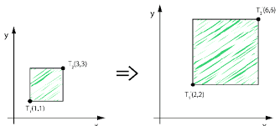



**Deep Learning (Neural Networks)**

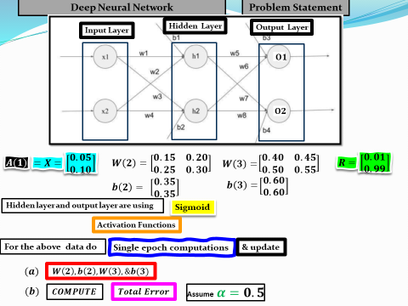

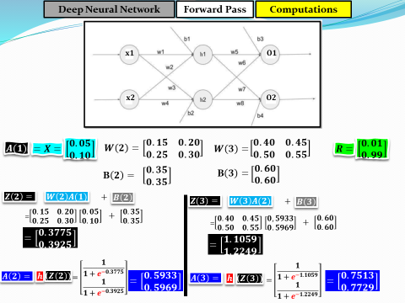

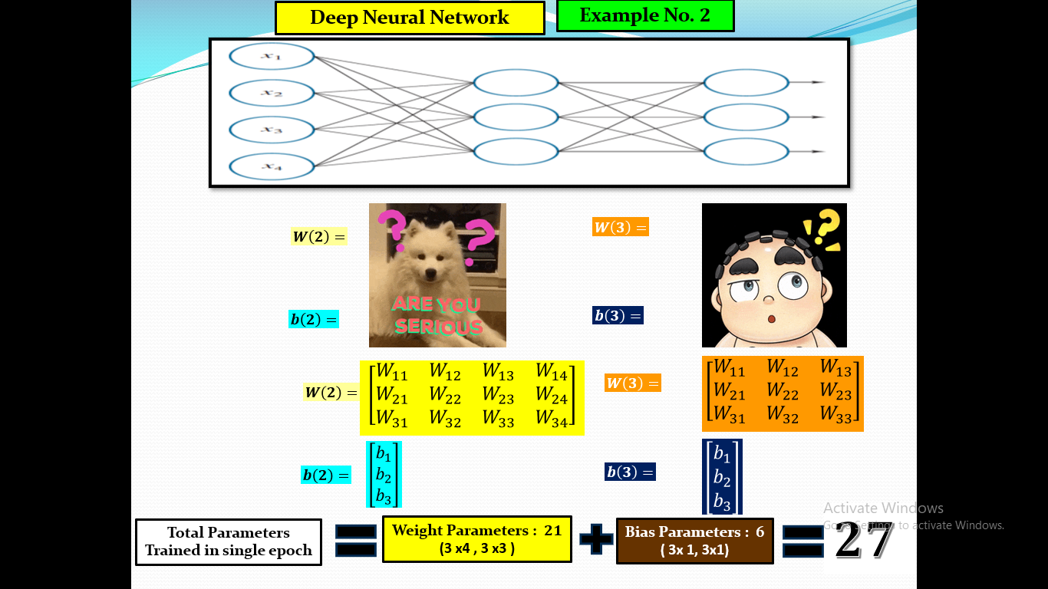

**Natural Language Processing – Vector Spaces**

NLP is a field of artificial intelligence that focuses on enabling computers to understand, interpret, and interact with human language.

It involves teaching machines to process and analyze large amounts of natural language data, such as text or speech, to perform tasks like translation, sentiment analysis, and speech recognition.

* 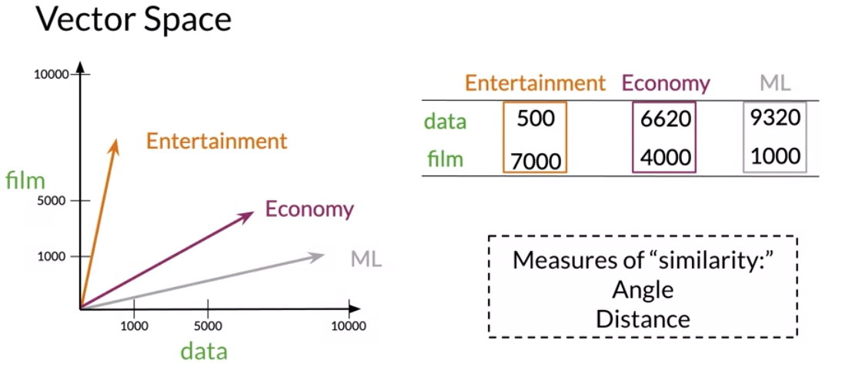

**Application Of Linear Transformation:**

[**https://youtu.be/Cb4aoihvh-o?t=24**](https://youtu.be/Cb4aoihvh-o?t=24)

**Some Topics of Linear Algebra:**

* System of Linear Equations
* Matrices
* Gaussian Elimination and Gaussian Jordan Method
* Vector Spaces
* Matrix Transformation
* Cryptography
* Eigen Values and Eigen Vectors and its applications to Machine Learning.

**Linear Equation**

An equation whose exponent or power is one is called linear equation.

**Examples:**

1. 🡪 One Variable
2. 🡪 Two Variables
3. 🡪 Three Variables
4. 🡪 Four Variables
5. 🡪 n Variables

Linear equation does not involve any products or roots of variables. All variables occur only to the first power and do not appear as arguments of trigonometric, logarithmic, or exponential functions.

**Linear Equation in General**

The equation

🡪 (1)

which expresses the real quantity *b* in terms of the unknowns and the real constants is called a linear equation.

Q. The following equations are linear or nonlinear? If it is nonlinear which term in each equation is making it nonlinear?

**Exercise 1.1 [***Elementary Linear Algebra with Applications by* ***Howard Anton*]**

1. In each part, determine whether the equation is linear in and .

**Solution of a Linear Equation**

A **solution** to Linear Equation (I) is a sequence of numbers

which has the property that (I) is satisfied when are substituted in (1).

For example: The equation

has the solution

Because on substituting these values, equation becomes identity i.e;

6

or

**System of Linear Equation in two Variables**

A system of linear equations in two variables and will have the form

Here are real numbers.

* To find a solution to a linear system, we already know two techniques called the

1. **method of elimination**
2. **method of substitution**
3. **We are going to learn new systematic techniques for complex systems.**

**Note!** Solution from any of these methods will remain same.

**Example 1** Find the solution of the linear system by using method of elimination.

**Solution**

We want to eliminate y, so by adding both equations we get:

Put value of in first equation

So (1, -2) is solution of the given system.

**Example 2** Find the solution of the linear system by using method of elimination.

**Solution**

We want to eliminate x, so by multiplying equation (1) by ``2’’ and subtracting from (2), we get

which makes no sense. This means that the given system has no solution.

**Consistent and Inconsistent Linear System**

If the linear system has no solution, it is said to be **inconsistent**, if it has a solution. it is called **consistent.**

So the system in example 1 is consistent and in example 2 is inconsistent.

**Note!**

A consistentlinear system of two equations in two unknowns has either one solution or infinitely many solutions--there are no other possibilities.

7. In each part, determine whether the given point is a solution of the linear system

1. (3, 1, 1) b) (3, -1, 1) c) (13, 5, 2)

d)

1. In each part, determine whether the given point is a solution of the linear system

**Work to do:**

Exercise 1.1 Q 1-10